Appendix

Chapter 1

Chapter 2

Chapter 3

Visibility Gaps
When communicating about gaps in the current monitoring practice I use the following Figure Appendix 3-1 to get the point across.
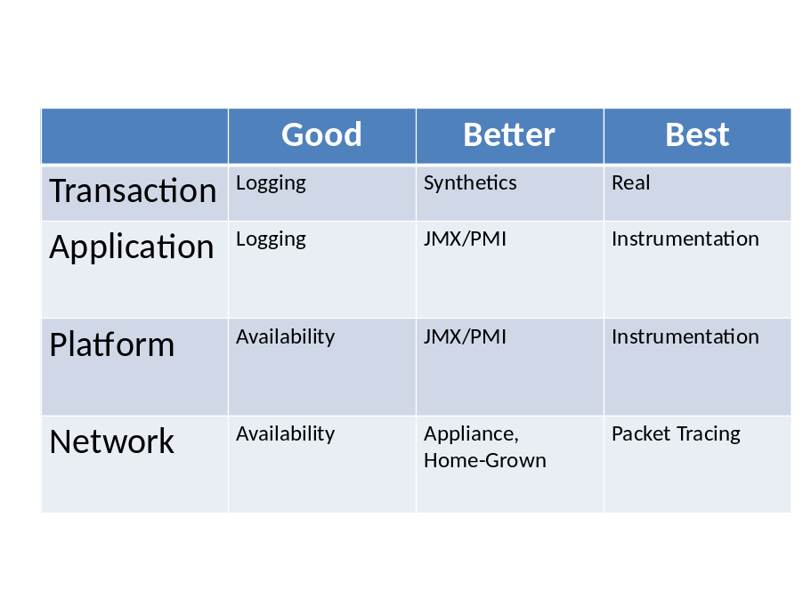
Figure Appendix 3-1 – Monitoring Visibility

This graphic captures the two perspectives, business and IT, in terms of what information has the most meaning for their respective roles, and how obtained. The left column illustrates the monitoring capability stack while the remaining columns capture the increasing monitoring capability, in terms of the technology used. The column headings follow the theme of “Good-Better-Best” to show the evolution of capabilities for the organization.
Another perspective, albeit a bit more pejorative, is to change these column headings to “Day-Hour-Minute” and see how your reporting intervals line up. When an organization is dependent on logging and reactive-negoiated sharing of alert status, it is really reporting of performance at daily intervals. This is usually a reporting frequency established by the service provider, as part of their monitoring agreement, and can represent a significant barrier to achieveing meaningful progress on the APM initiative.
A mature APM discipline eliminates these artificial barriers to access of performance information information and alert status, making the information available near real-time. This allows stakeholders to respond and restore performance in more timely fashion, and also foster collaboration by relaxing strict control on who can access the information.

Types of Applications
BATCH |  |  |  | Scheduled, non-interactive operations running once or several times per day
SEMI-BATCH |  |  |  | Unscheduled or on-demand non-interactive running once or several times per day
Scriping Language (Perl, etc.) |  |  |  | Application built from Perl or TCL scripts.
WEB-INTERACTIVE |  |  |  | Browser accesses various functionality, initiates tasks and participates in workflow
WEB-EAI |  |  |  | Browser-based Integration architecture against multiple back-end systems such as SAP, PeopleSoft, etc.
WEB-SOA (web service) |  |  |  | Service-oriented architecture - automated, higher volume access to Web infrastructure
WEB_CLOUD |  |  |  | Service-oriented architecture - Service Provider virtualized, scalable volume access to Web infrastructure
LEGACY-CLIENT-SERVER (please note) |  |  |  | Any non-http-based protocol for client-server
MESSAGING-MIDDLEWARE |  |  |  | Asynchronous delivery of requests and data
TRANSACTIONAL-MIDDLEWARE |  |  |  | Synchronous delivery of requests and data
EVENT-MIDDLEWARE (note vendor) |  |  |  | Asynchronous delivery of requests and data (Tibco, Vitria, WebMethods, etc.) Please specify vendor.
B2B_EDI |  |  |  | Classic Electronic Data Interchnage (WICS, Commerce One, Cyclone Data, etc.) Please specify vendor.
B2B_SWIFT |  |  |  | Financial services Data Exchange
B2B_HIPAA |  |  |  | Insurance Services Data Exchange
B2B_ROSETTANET |  |  |  | Data Exchange based on RosettaNet standards
WORKFLOW |  |  |  | Coordination of Human-mediated tasks and approvals
WORKFLOW-HIGH-VALUE |  |  |  | Coordination of Automated tasks and approvals (provisioning, ordering, logistics)
PACKAGED-APPLICATION (note vendor) |  |  |  | Siebel, Ariba, SAP, Oracle, PeopleSoft etc.
PORTAL-IN-HOUSE |  |  |  | Propritary portal solution not based on an 3rd party portal development environment
PORTAL-WEBSPHERE
PORTAL-WEBLOGIC
PORTAL-OTHER (describe in notes) |  |  |  | Any other 3rd party Portal solution

Chapter 4

APM Roles – Full Details

APM Administrator
ACTIVITY | Tasks
Server Configuration and Operation | Operating System configuration, tuning and updates  Application Server and Database configuration and tuning  Server Startup, Shutdown
Software Deployment and Configuration | Application server and database updates  Application code deployment
Updates and Upgrades | Change control practices
Other Responsibilities | Deploy initial agent configuration for various application servers. Establish a reusable profile for application teams to employ directly, if appropriate.  Deploy APM metrics storage component, APM workstations.  Manual editing of configuration files as appropriate  Packaging and transfer of files, software distribution  Maintain repository of version specific documentation, to initiate APM agent install, APM metrics storage install, APM workstation install  Maintain monitoring tool runbook

APM Project Manager
ACTIVITY | Tasks
Coordinate of Tactical Services Engagements | Identify monitoring/practice needs, Define and Scope engagement  Schedule staff availability concurrent with the engagement  Participate in Kickoff and Wrap-up meetings to ensure that Scope is achieved and Scope Creep is avoided
Deployment Planning | Initiate Application Survey for candidate applications, Track current and projected EM capacity, Coordinate Metrics Storage Sizing and Platform selection  Coordinate schedules for QA testing with monitoring enabled  Coordinate definition of alerts, dashboards and reports to meet business requirements, Coordinate definition of “Gold” configurations for agents and Metrics Storage, Document problematic applications and remediation  Coordinate schedules for production planning, alert definition and integration  Document production incidents and monitoring configuration change requests
Maintain the Plan of Record | Document the requirements, exceptions, outstanding deliverables, incidents and remediation
Review Incidents related to APM Tools | Document incidents by application, environment (prod, QA, etc.) and resolution
Other Responsibilities | Initiate Application Survey, Initiate service engagement justification and scope, Document success of engagements  Define deployment scope and schedule, Project Closure, Coordinate/schedule contributors in the application lifecycle  Development definition of critical code areas  QA Testing  Alert Definition and Integration  Performance escalation and remediation, Product Packaging Standards  Trouble Management, Triage Teams, Capacity Planning Teams

Application Specialist
ACTIVITY | Tasks
Software Development Lifecycle | Liaison with all stakeholders in the application lifecycle: Application Solution Design, Development and Unit Test, Functional and Performance Test, Pre-production and User Acceptance, Operations, Firefighting
Business and IT Metrics | Definition of KPIs and metrics assignment among available monitoring technologies, review Platform metrics  Availability, Performance and Capacity metrics, End user experience metrics  Business value of key transactions, Business cost of availability or performance incidents
Time-to-Market Strategies | Solution quality acceptance criteria  Risk analysis in deploying unstable or untested releases  Contingency for remediation of performance incidents, pre- and post-production
Other Responsibilities | Design of Application –specific dashboards and reporting  Alert integration strategy, Guidance for triage activities, Establish acceptance criteria, Supervision of efforts to extend agent visibility

APM Architect
ACTIVITY | Tasks
Estimating App Complexity | Client-server Solution Architectures , Application Design Strategies
Determining Appropriate Monitoring Technology | Assessing Application Value, Visibility and Overhead, Monitoring Tools and Strategies
Assessing End-to-End Environment | Solution quality acceptance criteria, Risk analysis in deploying unstable or untested releases ,Contingency for remediation of performance incidents, pre- and post-production
Alert Integration and Goals | Defining which alerts are propagated, Ensuring there is an appropriate response to the alert
Forecasting APM Performance and Capacity Utilization | Review Performance and Capacity Reports, Review utility and suitability of upgrade opportunities, Schedule hardware and software upgrades
Sizing of the Metrics Storage for Enterprise Deployments | Hardware principles – choosing HW to support metrics storage  CPU, Benefits and limitations of multiple CPUs, Disk I/O, Drive controllers, SAN technologies, Network Interfaces, single and multiple NICs, Memory and Cache, Physical RAM, Operating System configurations, Characteristics of real-time software
Other Responsibilities | Survey of candidate applications, Monitoring tool identification and implementation., Coordination of tool responsibility., Monitoring Solution Planning and Sizing, Definition of monitoring tool user competency., Definition of QA testing procedures and reporting when instrumentation is employed, Definition of Acceptable QA performance characteristics, Definition of Key metrics, Dashboards and Reporting, Strategy for Custom Tracing and extension products to enhance visibility, Alert integration strategy  Strategy to archive reports and historical metrics (greater than 1 year)

APM Specialist (Triage/Firefighter)
ACTIVITY | Tasks
Managing Expectations | Importance of accurate and repeatable exercise of the application  Load Generation profiles (QA/UAT/Stress), Consistent operational periods (production), Use Case testing and Stress Testing, Validation monitoring configurations (visibility), Identify transaction characteristics and impact on resources, Identify scalability point if load-to-failure can be achieved, Limitations of dynamic instrumentation
Communicating Remediation | Presenting monitoring findings in a non-inflammatory manner, while retaining integrity and conviction
Other Responsibilities | Scope and LOE estimates, Installation or supervision of APM components  Installation or supervision of initial agent configuration into QA  Coordination of initial load testing in QA, Validation of agent configuration  Outline of production deployment procedures, Deployment to production of EM and Agents, Review and Analysis of Operational and QA findings, Presentation of Findings and Recommendations  Assessing the apparent and verifiable characteristics of the application environment, Identifying anomalous behavior in a non-judgmental fashion  Prioritizing opportunities to correct defects, Rerunning tests after initial changes are made in order to document new performance, and characteristics of the fix/miss, and identify new priorities

Chapter 5

Chapter 6

Chapter 7

Chapter 8

Chapter 9

Chapter 10

Chapter 11

Chapter 12

Chapter 13

Chapter 14

Chapter 15

Chapter 16

Chapter 17

Chapter 18

